

A Project Report

On

**CHEMICAL INVENTORY SYSTEM**

By

**Vaishnavi Tarhal**

**MSc. (Computer Science)**

**Batch: - 2020 – 4965**

**Center :- Pune Chinchwad**

**Under the Guidance of**

**Jayant V.**

**Technical Trainer**

**EduBridge**

**(School of coding)**

**INTRODUCTION:**

This Project explains about Chemicals Inventory System. That is any student studying about chemicals research, proffessors and any scientist can get chemicals from this system.

There are two modules,

1. Admin
2. Customer

I have developed this Application in Java, JSP, Servlets and MySQL. It’s a web based projects so I have used HTML, CSS also.

The main feature of the project is to manage the records of chemicals. In Admin module, I created Curd Operation where Admin can add New chemical, Update, and Delete and also View their whole records of the chemicals. In Customer module, customer can see the chemical Details and also get information about them.

**Software Requirements:**

Front end: Java/J2EE technologies (JSP), HTML, CSS, JDBC

Back end: MySQL.

Middleware/Server: Apache Tomcat v9.0.

IDE: Eclipse IDE for Java EE Developers

Browser: Best result on Google Chrome

Operating System: Window 10

**DATA DICTIONARY:**

Database: Chemicals

**1.Table name: register**

create table register(salutation varchar(20) not null ,

fname varchar(20) not null,

lname varchar(20) not null,

email varchar(30) primary key not null,

password varchar(30) not null,

phone_no varchar(10) not null,

job varchar(30) not null,

address varchar(60) not null);

**2.Table name:product**

create table product(cas_no int primary key not null,

chem_name varchar(30) not null,

GST int not null,

pack_size int not null,

rs_per_pack int not null);

**SCREENSHOT:**

**1.Home page**



**2.Admin Login**

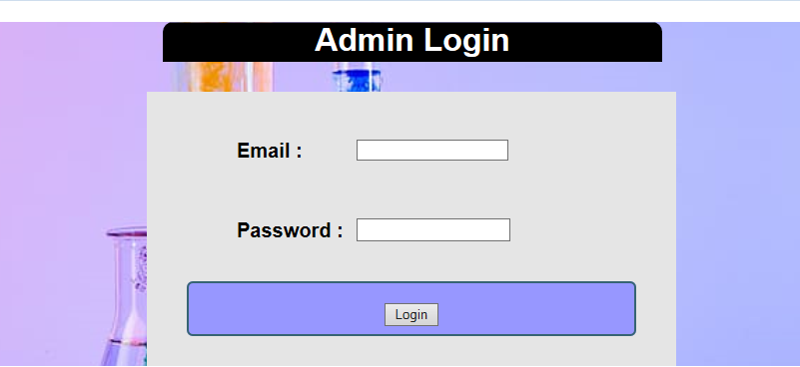

**3.Admin crud operation**

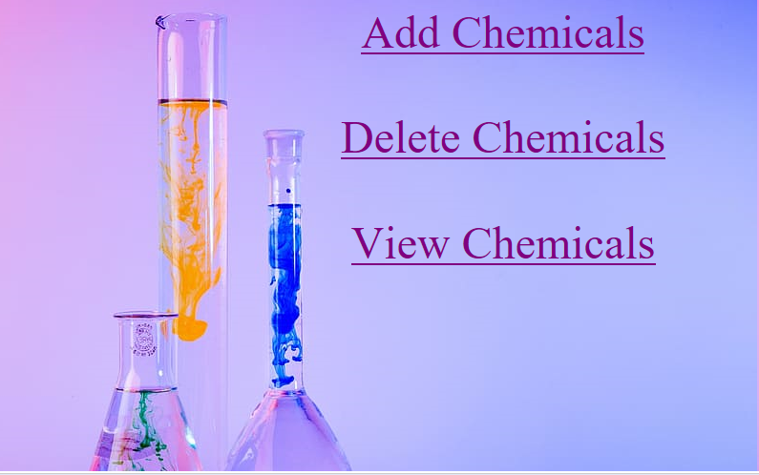

**4.Add new chemical**

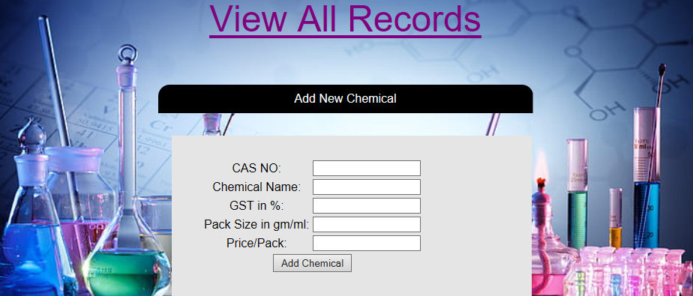

**5. View Chemicals**

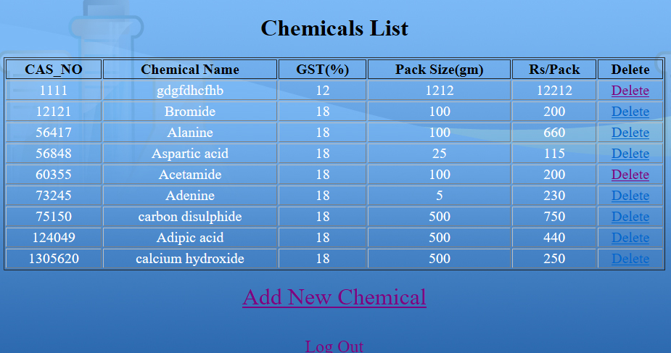

**6. chemical list visible for all**

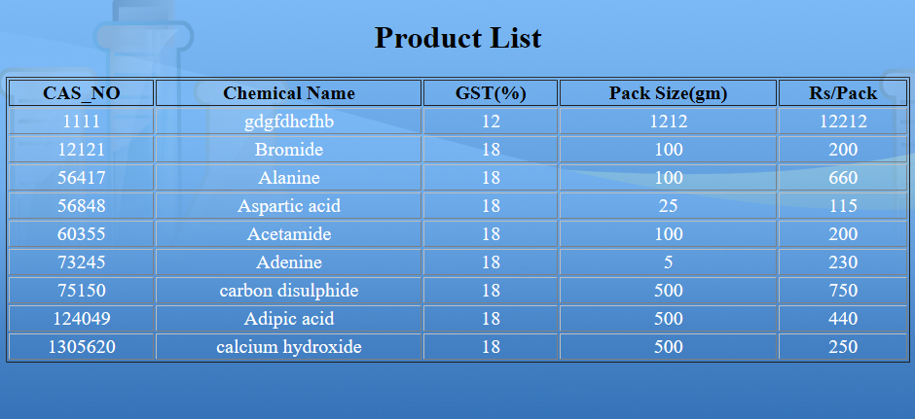

**7.references given**



**8. Contact**

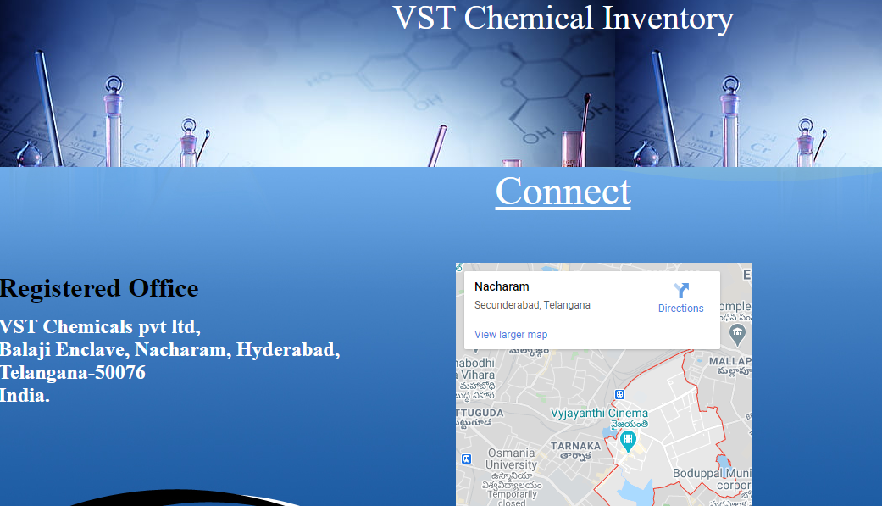

**9. Customer Account registration**

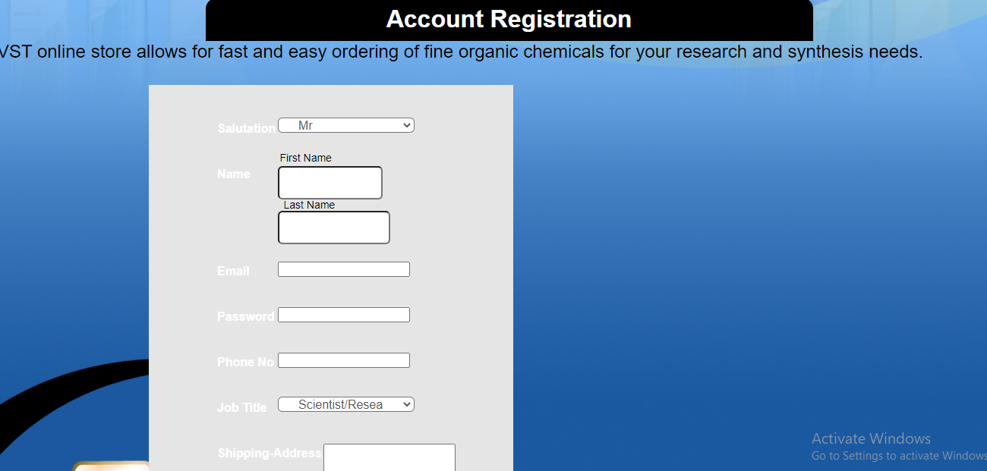

**10. Customer login**

